**Ideation Phase of TravelSphere**

**Brainstorm & Idea Prioritization Template**

| Date | 31 January 2025 |
| --- | --- |
| Team ID | SWTID1743511769 |
| Project Name | TravelSphere(Social media for travel enthusiast) |
| Maximum Marks | 4 Marks |

**Brainstorm & Idea Prioritization Template**

In the initial phase of our project development, we conducted multiple brainstorming sessions to generate innovative and diverse ideas. The goal was to explore as many creative solutions as possible without filtering or evaluating them prematurely. Our approach encouraged each team member to contribute freely, promoting a collaborative and judgment-free environment.

We followed these steps to structure our brainstorming and prioritization process:

* **Step 1: Problem Understanding**Clearly defined the main problems we aimed to solve (e.g., seamless travel booking, real-time communication, personalized recommendations).
* **Step 2: Idea Generation** Each team member shared ideas openly using tools like virtual whiteboards, sticky notes, and Miro. We emphasized quantity over quality in this phase.
* **Step 3: Categorization**Ideas were grouped into categories such as UI/UX improvements, backend services, personalization features, and user engagement tools.
* **Step 4: Prioritization**We applied the ICE Scoring Model (Impact, Confidence, Ease) to evaluate each idea and decide which ones to implement based on feasibility, innovation, and value.
* **Step 5: Final Selection**Top-scoring ideas were shortlisted and converted into actionable tasks and milestones.

Link:<https://app.mural.co/t/travelgram7894/m/travelgram7894/1743877900278/751a3f6ee41620ef47143f24156c49249234ca59?sender=u1e90317ebed16c4cd93d8252>

**Step-1: Team Gathering, Collaboration and Select the Problem Statement**

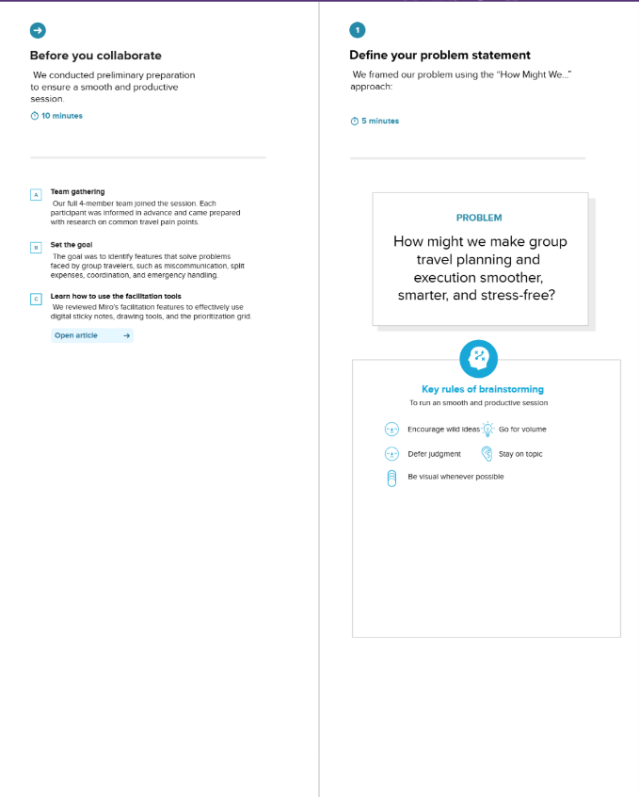

**Step-2: Brainstorm, Idea Listing and Grouping**

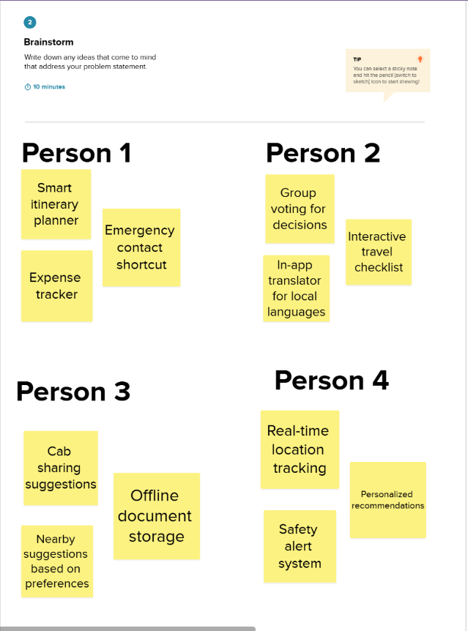

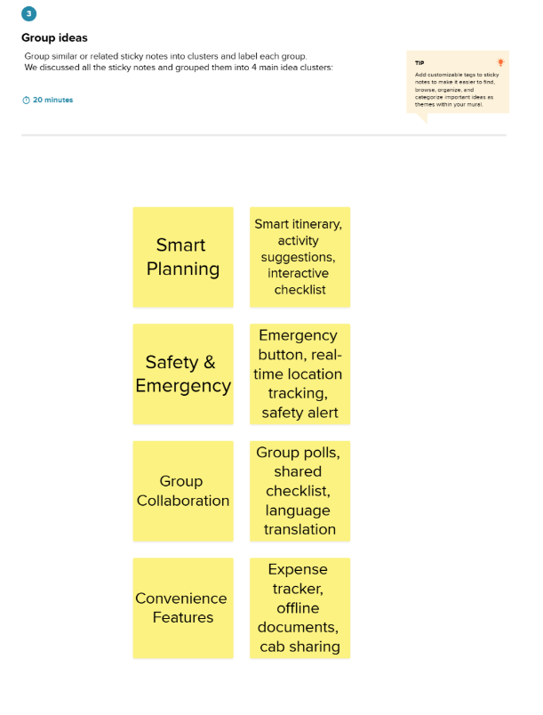

**Step-3: Idea Prioritization**

